Analytics Portal Bug List:

1. When Click any modules in the portal, invalid error toast is appeared.

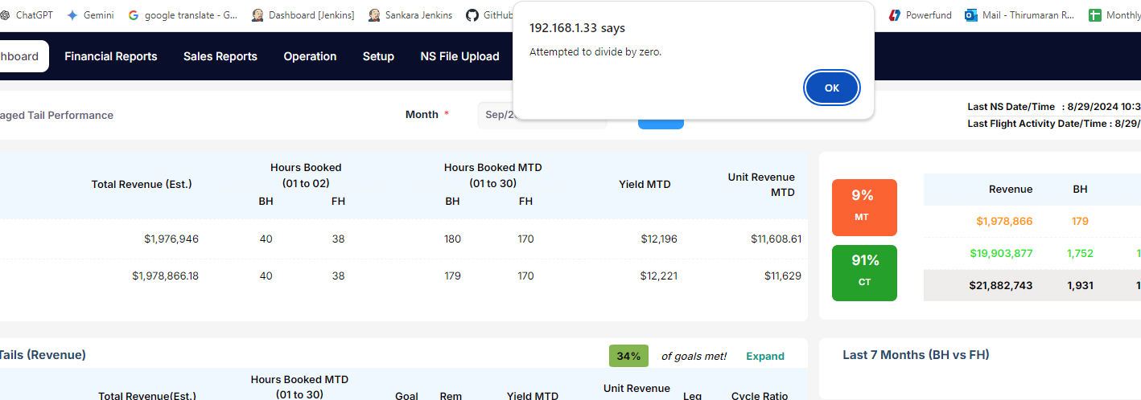

1. Sales Reports-Cost analysis(By Airport)-After select jul/2024 in from tab and Aug/2024 in to tab and select valid aircraft and select valid metrics and click view button, in trasaction tab,End of the page shows improper values.

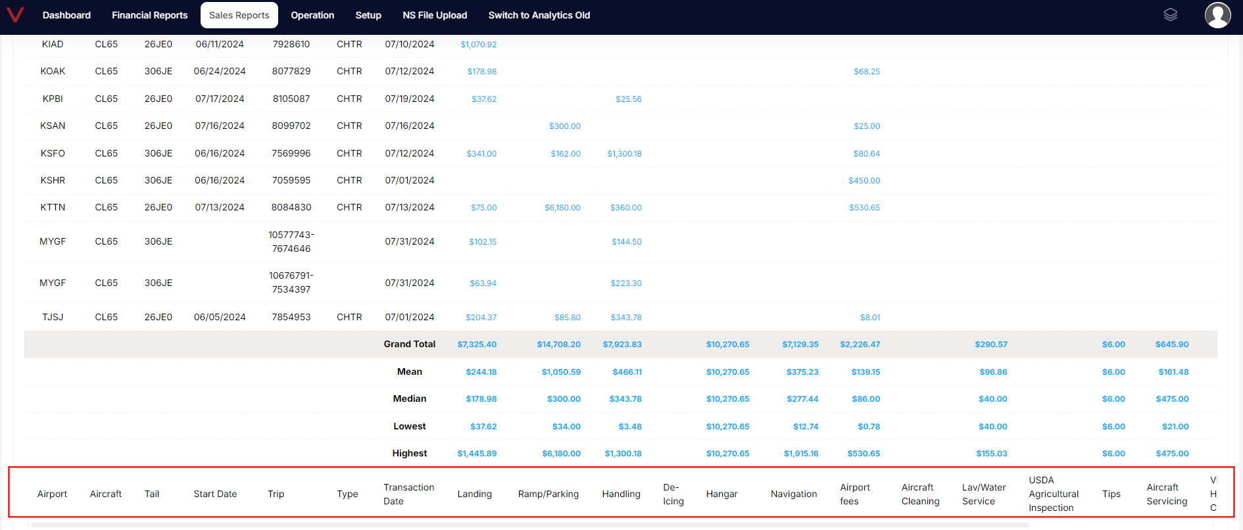

1. Sales Reports-Cost analysis(By Airport)-After select jul/2024 in from tab and Aug/2024 in to tab and select valid aircraft and select valid metrics and click view button, in trasaction tab, the table when click numeric values in the table page displayed invalid error toast. May be need to remove the clickable option.

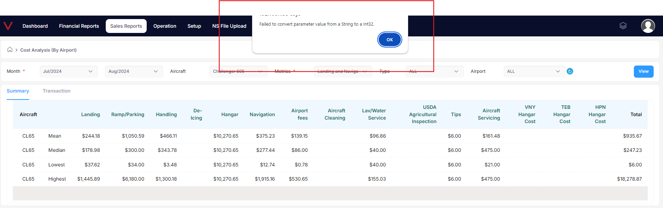

1. Sales Reports-Cost analysis(By Trip)- In metrics dropdown, first option displayed as “ALL” option but it need to show “Please select” option.

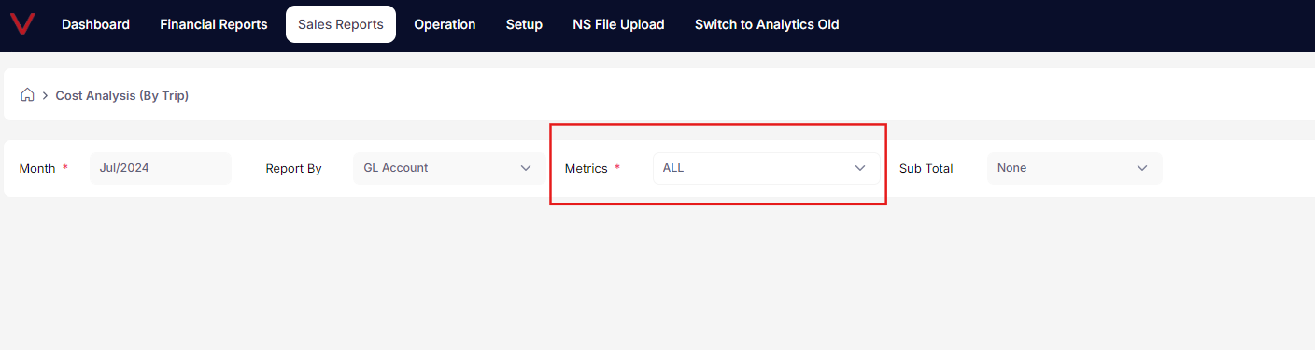

1. Sales Reports-Cost analysis(By Trip)-Select Jan/2022 month, select group option in report by tab, in metrics tab select “IPSR” and click view button, invalid error toast appeared.

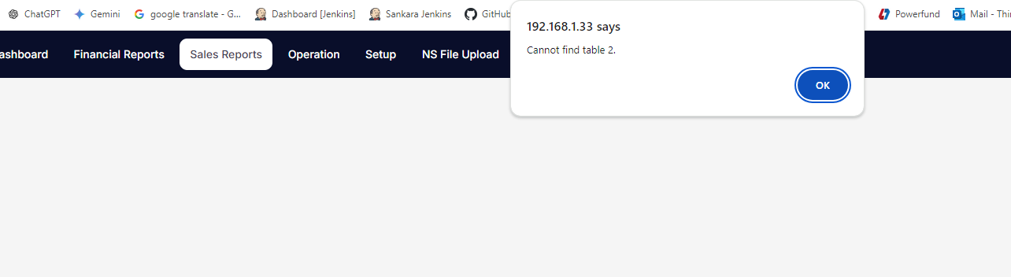

1. Financial Reports-Route Profit-When enter to this page calenndar tab is empty.

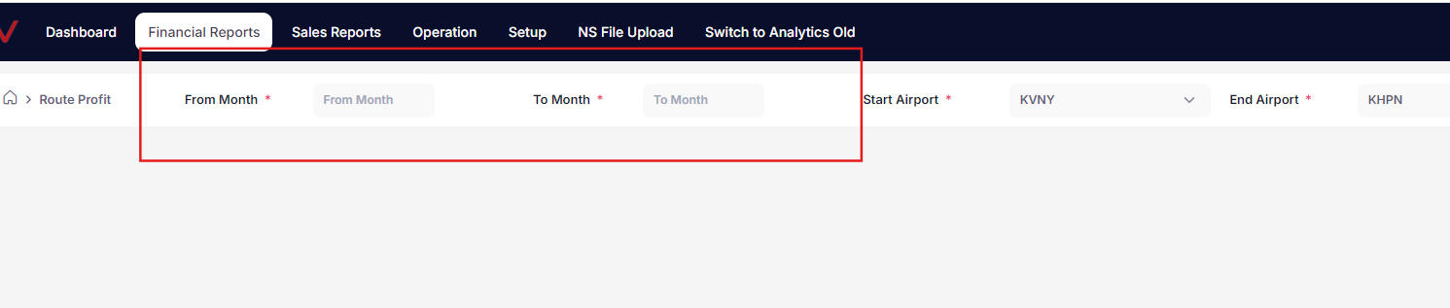

1. Financial Reports-Route Profit-When click from and to calendar(Both calendar), details is not properly displayed. If scroll down details gets displayed properly. Bt it shouldnot like this.

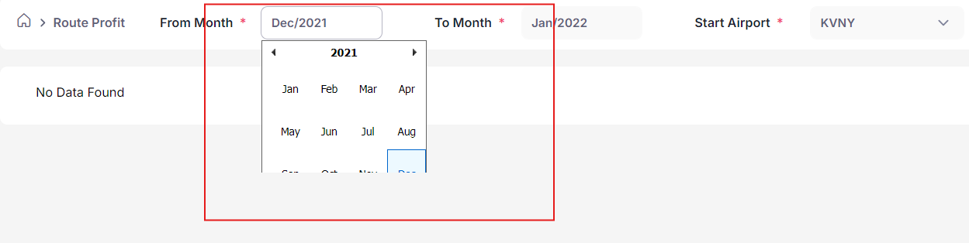

1. Financial Reports-Cost accural-Select Jan/2024 and click run button, table displayed valid details, Click trip number in the table, after that pop up opened without any issues and click close button. Then pop up is closed. After that, perform any actions in the same page, same pop up is raised.

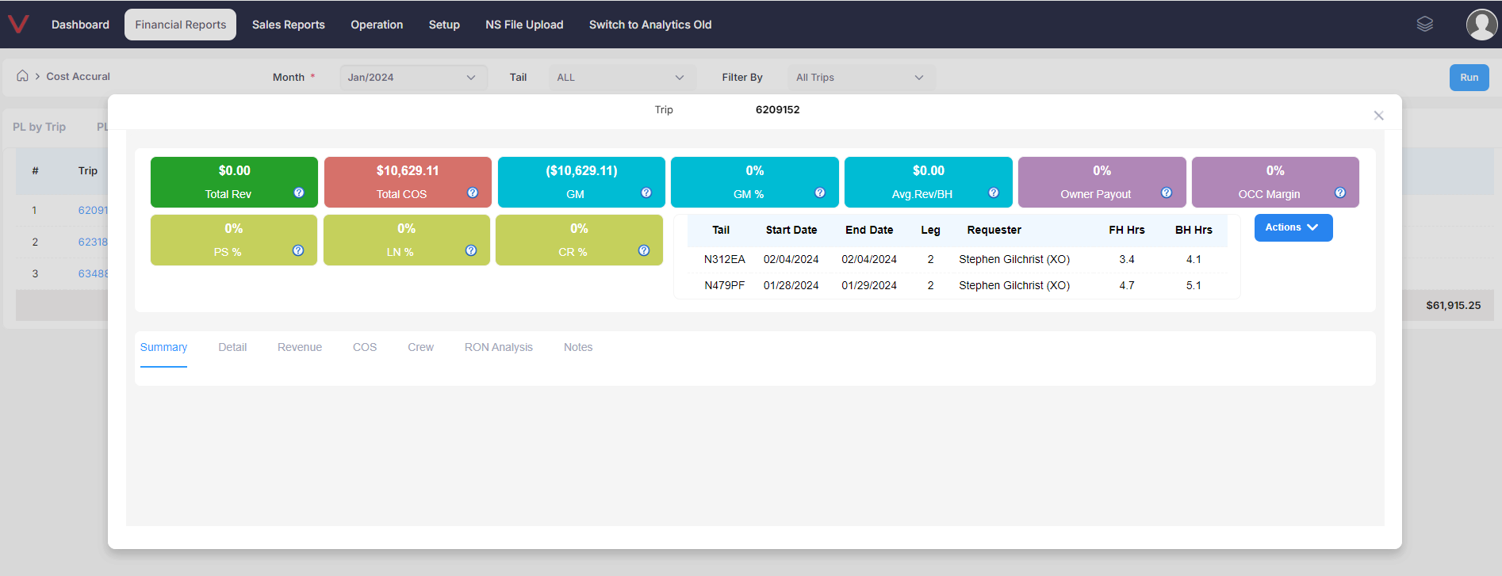

1. Three type of alert message is displayed. Need to show only one type.

* In Financial reports-Tail rank:

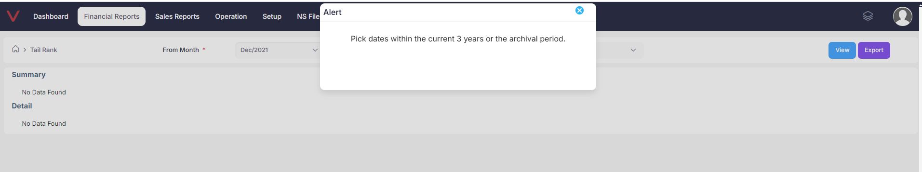

* In sales reports, sales by tail:

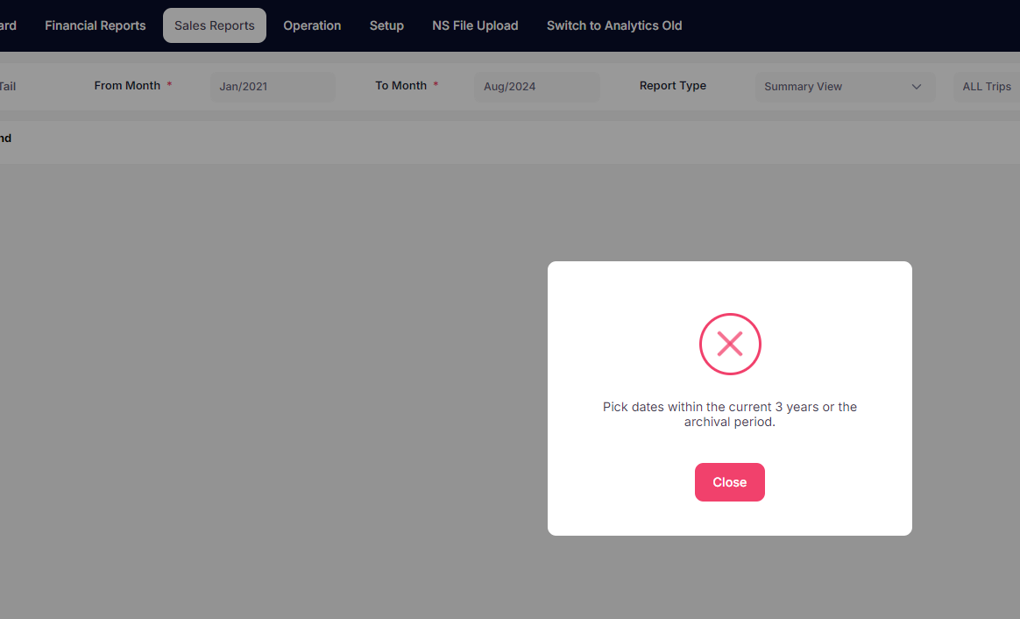

* In Financial Reports-P/L by trip- select trip option and click view button, then,

Dec/2021 in from month and Jan/2024 in to month and click submit button error toast appear like this.

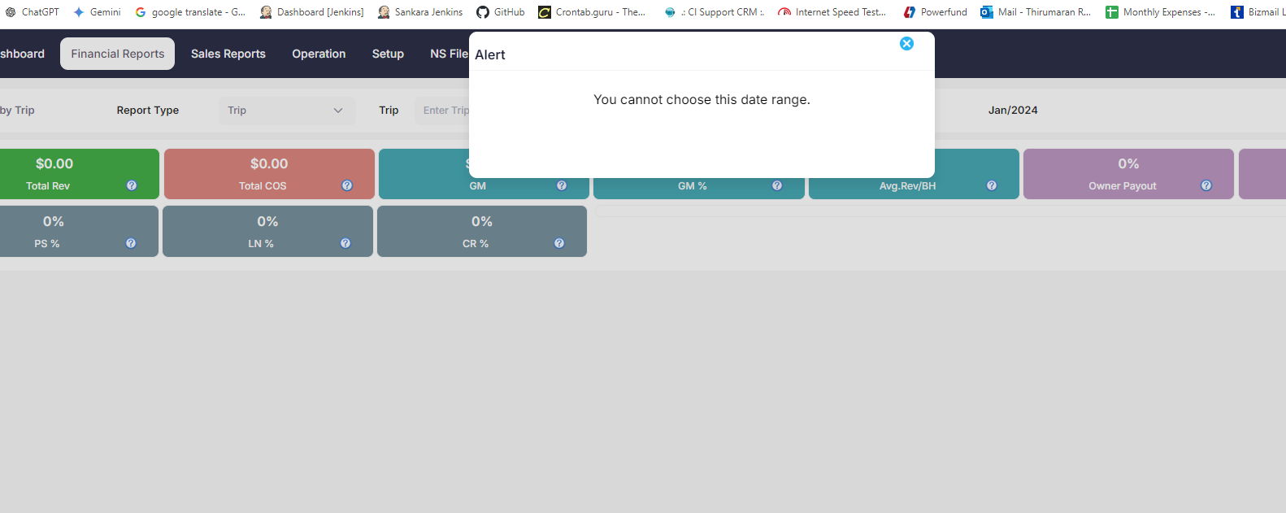

1. Financial Reports-P/L Trip-Select valid report type-And click view button-Select valid month in from and to tab and click submit button. Then click crew tab button and click roster button invalid error toast is displayed.

